Ghent welcomes Europe's largest scientific conference on animal production
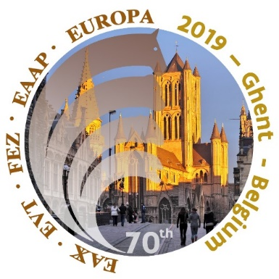
From 26th to 30th August 2019 ILVO organizes the annual EAAP Congress on animal production in the International Congress Center (ICC) in Ghent. During this 70th edition, more than 1,300 scientists, experts and stakeholders from the business community and government will focus on the theme "Animal farming for a healthy world. The meeting is the hot spot for animal production in Europe for 5 days. Exchange of scientific knowledge and international contacts with research, policy and industry are crucial in a unique historical context of Ghent.
Animal farming for a healthy world
"Animal production for a healthy world" is the main theme of this edition. In 73 sessions with a total of more than 700 lectures and 540 posters on topics such as genetics, nutrition, management, animal welfare, agro-ecology, climate change, ecological footprint and product quality, the congress will address the most important of current societal concerns on animal production. The extensive scientific program covers the various sectors of the animal sector: cattle, pig and poultry farming, but also horses, insects, sheep and goats. More info about the program can be found on the EAAP website (https://www.eaap2019.org/).
More than science…
In addition to scientific lectures and poster sessions, the congress will also include informal networking opportunities and social activities to establish contacts between people active in research institutions, governments and the business community. Of course the culinary and historical assets of Ghent and Belgium play an important role in this. The specificity of the Belgian agricultural sector is also highlighted during 4 technical excursions on the last congress day. Each of these emphasizes some of the strong and/or innovative aspects of our Belgian agricultural sector: highly muscled meat breeds, aquaculture, insects, horse breeding, goat farming, family farms, efficient feed production and research.
The main objective of EAAP is the development and dissemination of knowledge, as well as international cooperation between the various stakeholders in animal production. With the program of the 70th EAAP Congress, this is clearly evident. In this way, the animal production sector can continue to innovate and new contacts can form the basis of future cross-border cooperation.
In short, this is a unique opportunity to gain knowledge, expand your network and promote the Belgian agricultural sector with us.
More info: www.eaap2019.org or contact Sam De Campeneere (info@eaap2019.org)
Registration: www.eaap2019.org/EN/REGISTRATION

